Pharmaceutical Drug Sales Analysis using SAS

Comprehensive Business Analytics Project Documentation

Project Executive Summary
This project presents a detailed and structured analysis of pharmaceutical drug sales data using SAS, with the objective of converting raw, unstructured transactional data into meaningful and actionable business insights.
In real-world business environments, raw data often lacks clarity and cannot directly support decision-making. Therefore, this project focuses on building a complete analytical pipeline that includes data cleaning, transformation, feature engineering, exploratory data analysis, and statistical evaluation.
Through this process, the project successfully identifies key performance drivers across products, regions, and time periods. It provides a clear understanding of which products contribute most to revenue and profit, how different regions perform, and how sales vary over time.
The outcomes of this analysis are designed to support business stakeholders in making informed decisions related to product strategy, regional expansion, pricing optimization, and operational planning.

Business Problem Statement
Pharmaceutical companies operate across multiple regions and manage a diverse portfolio of products. While large volumes of sales data are generated daily, organizations often face challenges in extracting meaningful insights from this data.
Some of the key business problems addressed in this project include:
- Lack of clear visibility into which product is the most profitable
- Difficulty in identifying high-performing and underperforming regions
- Absence of structured analysis for monthly and seasonal trends
- Limited understanding of the relationship between sales volume and profitability
- Inability to convert raw data into strategic business insights
Without proper analysis, decision-making becomes reactive rather than data-driven. This project addresses these challenges by applying a systematic analytical approach using SAS.

Project Objectives
The project was designed with clearly defined analytical and business objectives:
- To clean and standardize raw pharmaceutical sales data for accurate analysis
- To handle missing, inconsistent, and improperly formatted data
- To derive meaningful financial metrics such as revenue, profit, and profit margin
- To perform detailed exploratory data analysis across multiple dimensions
- To identify top-performing products based on revenue, profit, and demand
- To evaluate regional performance and contribution to overall business
- To analyze monthly trends and identify peak sales periods
- To understand the relationship between units sold, revenue, and profitability
These objectives ensure that the analysis is both technically sound and aligned with business needs.

4. Dataset Overview
The dataset used in this project consists of 120 transaction records, representing pharmaceutical sales across multiple regions and products .
Each record captures detailed information about a sales transaction, including product details, pricing, discounts, and location.

Key variables included in the dataset:
- Product Name – Identifies the pharmaceutical product sold
- Region – Indicates the geographical area of the transaction
- Units Sold – Represents the quantity of products sold
- Unit Price – Price per unit of the product
- Discount Percentage – Discount applied to the transaction
- Sale Date – Date on which the transaction occurred
- Sales Channel – Mode of sale such as online or retail
The dataset reflects real-world variability, including missing values and inconsistent formats, making it suitable for practical analytical scenarios.

5. Data Preparation and Transformation
Before performing any analysis, it was essential to ensure that the dataset was clean, consistent, and reliable. Data preparation plays a critical role in ensuring the accuracy of results and the validity of business insights.
Data preprocessing activities:

Handling Missing Values
Missing data can significantly affect analytical results if not handled properly. The following strategies were applied:
- Missing Sales Representative values were replaced with “Unknown” to maintain data completeness
- Missing Discount values were assigned a default value to avoid distortion in revenue calculations
- Missing numeric values such as Units Sold and Unit Price were handled using median imputation, which ensures that extreme values do not skew the dataset

Data Standardization
To maintain consistency across the dataset:
- Product names and region names were standardized using proper formatting
- Date values were converted into a uniform SAS date format for accurate time-based analysis

Feature Engineering (Derived Metrics)
Raw transactional data does not directly provide business insights. Therefore, several key financial metrics were derived:
- Revenue = Units Sold × Unit Price
- Discount Amount = Revenue × Discount Percentage
- Net Revenue = Revenue – Discount Amount
- Cost per Unit = Defined based on product-specific cost assumptions
- Profit = Net Revenue – Total Cost
- Profit Margin = Profit ÷ Revenue
These derived variables enabled deeper financial analysis and comparison across products and regions.

6. Detailed Analysis and Results

Product Performance Analysis
A comprehensive analysis of product performance was conducted to identify which products contribute most to revenue, profit, and overall business success.

Analysis findings:
- Top Performing Product (Based on Profit):
Painrelief-X generated a total profit of ₹ 29,38,95,370
- Top Performing Product (Based on Revenue):
Painrelief-X generated total revenue of ₹ 62,00,05,930

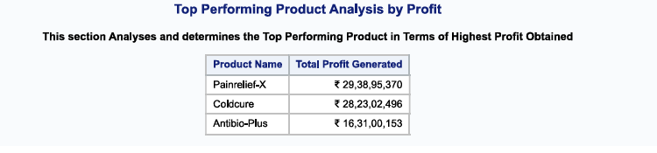
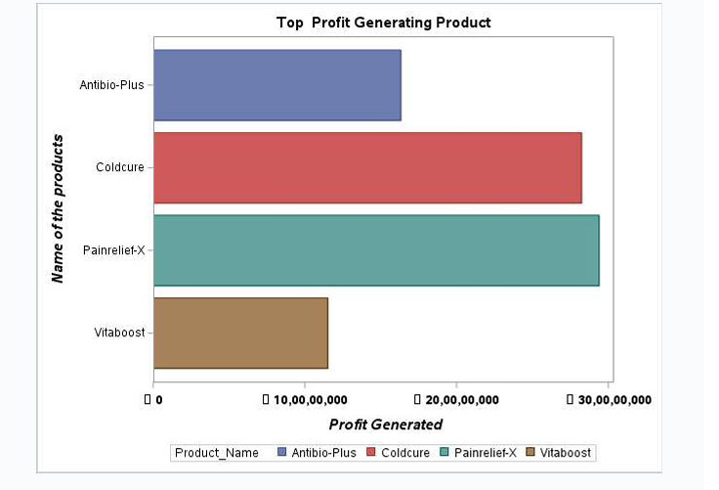

Interpretation:
Painrelief-X clearly stands out as the most important product in the portfolio. Its ability to generate both high revenue and high profit indicates strong market demand, effective pricing, and a well-balanced cost structure. It can be considered the flagship product of the business.

Additional product-level insights:
- Highest Average Revenue per Transaction:
Vitaboost recorded the highest mean net revenue of ₹ 1,96,50,193
- Highest Units Sold:
Painrelief-X achieved total sales of 240,714 units, indicating strong demand
- Highest Transaction Frequency:
Painrelief-X accounted for 40% of total transactions, making it the most frequently sold product

Interpretation:
- Painrelief-X dominates in both volume and financial contribution
- Vitaboost, while not the highest in total sales, generates higher value per transaction, indicating a premium positioning

Regional Performance Analysis
Regional analysis provides insights into geographical distribution of revenue and profitability.

Analysis findings:
- Top Revenue Generating Region:
South Region with total revenue of ₹ 58,12,14,808
Contribution: 31.38%
- Most Profitable Region:
South Region with total profit of ₹ 28,22,47,952
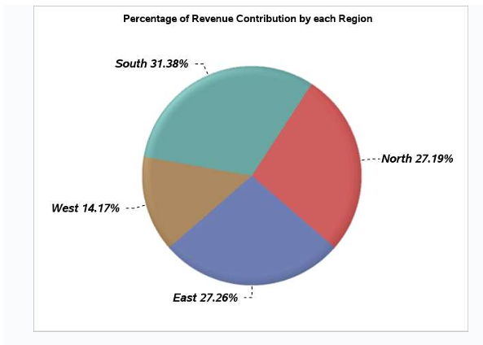

Interpretation:
The South region is the most significant contributor to overall business performance. It demonstrates strong sales volume and profitability, suggesting a well-established market presence and high customer demand.

Regional contribution breakdown:
- South → Leading contributor
- East and North → Moderate contributors (approximately equal share)
- West → Lowest contribution

Interpretation:
- The South region should be prioritized for business expansion
- The West region represents an opportunity for growth and improvement

Monthly Sales Trend Analysis
Time-based analysis helps in identifying patterns and seasonality in sales
- Top Performing Month:
February generated revenue of ₹ 47,52,97,604
- A declining trend is observed from February to April
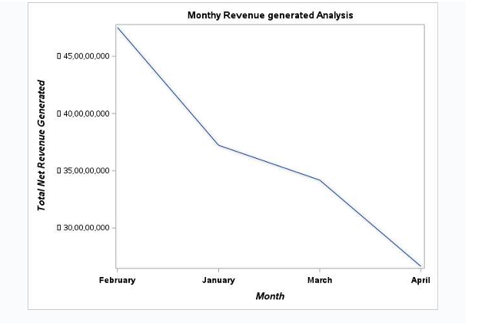

Interpretation:
Sales performance is not uniform throughout the year. The peak in February indicates potential seasonal demand, promotional activity, or market conditions that can be further analyzed and leveraged for future planning.

Region-wise Product Performance
Different products perform differently across regions, highlighting varying customer preferences and market conditions.

Observations:
- East Region → Painrelief-X performs best
- North Region → Coldcure leads in profitability
- South Region → Coldcure dominates profit contribution
- West Region → Painrelief-X performs best

Interpretation:
There is no single product that dominates across all regions. This indicates that customer demand varies geographically, and a uniform strategy may not be effective.

Correlation Analysis
Correlation analysis was conducted to understand the relationship between sales volume and financial outcomes.

Results:
- Units Sold vs Net Revenue: 0.69
- Units Sold vs Profit: 0.68
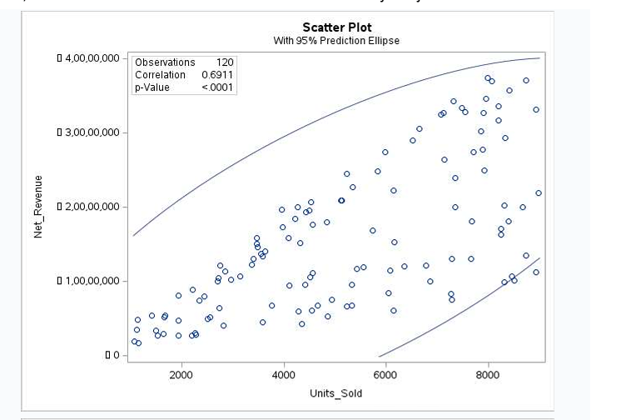
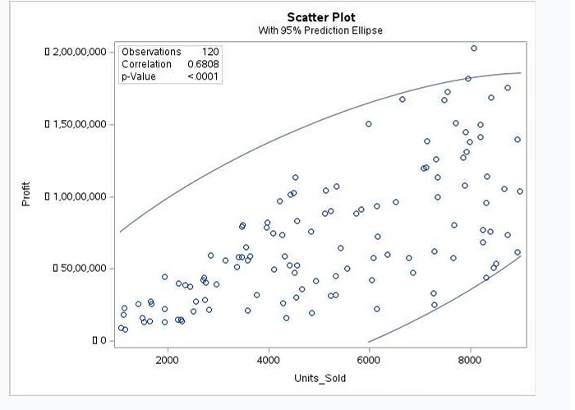

Interpretation:
There is a strong positive relationship between units sold and both revenue and profit. This indicates that increasing sales volume is directly associated with improved financial performance.

Region-wise correlation:
- West: 0.84 (strongest relationship)
- East: 0.74
- South: 0.70
- North: 0.62

Interpretation:
The West region shows the strongest relationship between sales volume and profit, making it the most predictable region in terms of performance.

Business Insights
The analysis provides several important insights:
- Painrelief-X is the primary driver of both revenue and profit
- South region is the most significant contributor to overall business performance
- February represents the peak sales period
- Sales volume has a strong impact on revenue and profitability
- Product performance varies across regions, requiring targeted strategies

Business Recommendations
Based on the analysis, the following strategic recommendations are proposed:
- Increase focus on production and promotion of Painrelief-X
- Strengthen market presence in the South region
- Develop targeted strategies to improve performance in the West region
- Utilize seasonal trends to optimize marketing and inventory planning
- Implement region-specific product strategies based on demand patterns

Project Conclusion
This project demonstrates a complete and structured approach to data analysis using SAS. It successfully transforms raw data into meaningful insights that can support strategic decision-making.
The analysis highlights key performance drivers and provides actionable recommendations for improving business outcomes.

